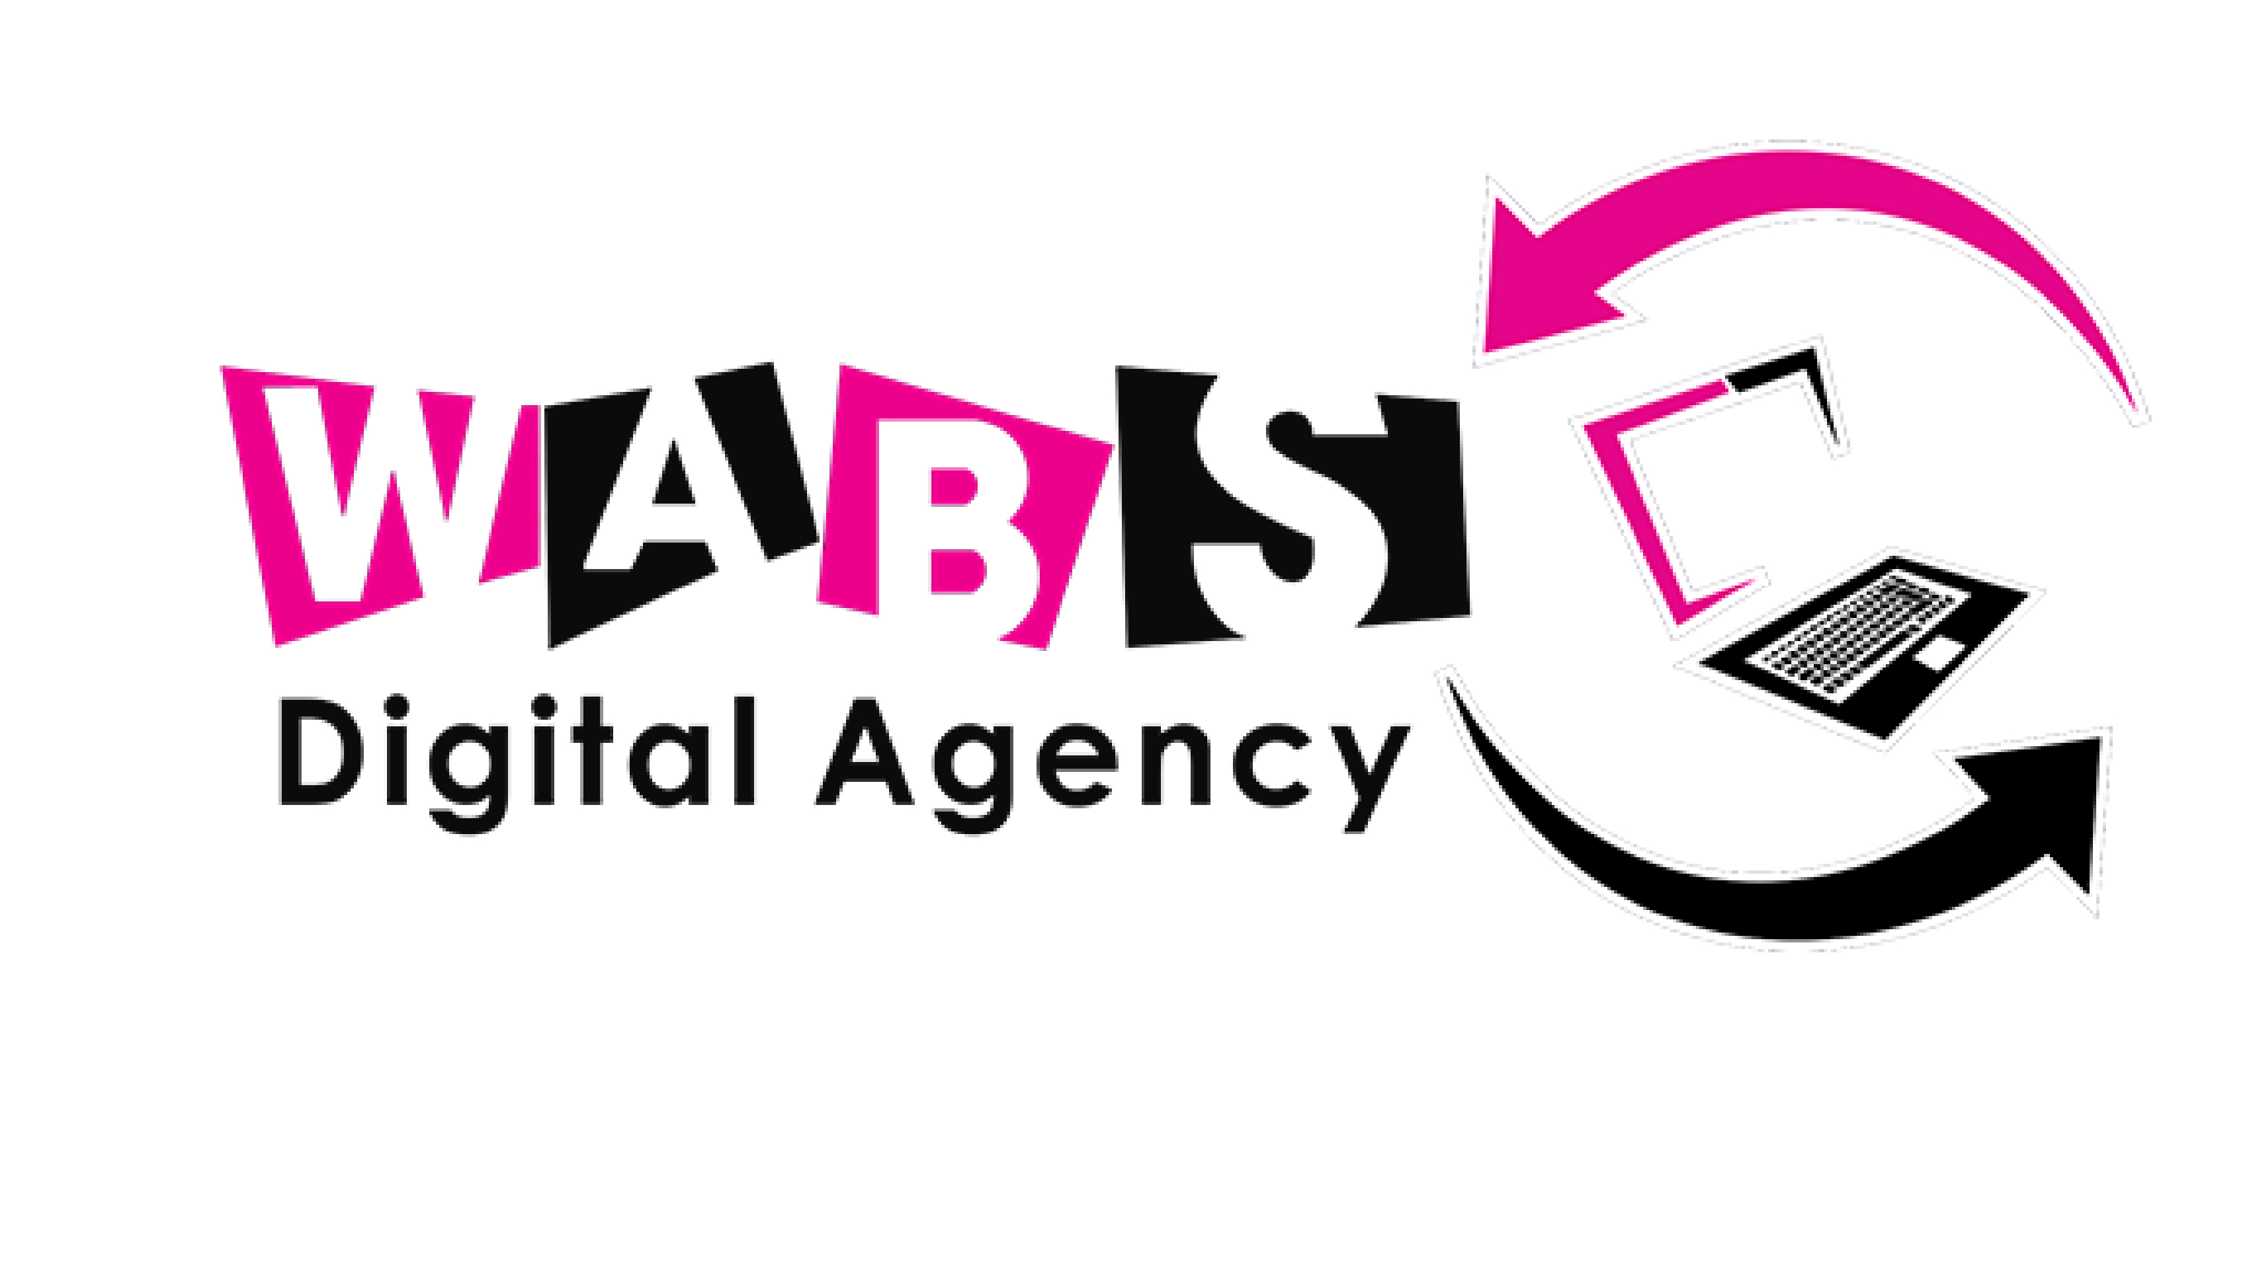
Strategy Always Comes First.
4Wk Digital Launch and Marketing Program
Option One — Learn Marketing First
This is not a course. It is a practical, done-with-you program to launch and grow your digital visibility.
Learn how to market your business properly before hiring too early — and walk away with a complete brand foundation built for you.
Not a passive course you sit through and forget. Not generic templates you fill in on your own. Not theoretical advice without real outputs.
A done-with-you engagement — we build your brand foundation alongside you, week by week, in the order that actually works: foundation and visibility first, then packaging and lead capture, then organic content and outreach, then paid growth with the payments to match.

Choose How You Want To Work With Us
Some founders are ready to commit to the full 4-week transformation. Others just need one specific piece solved right now. Either way works — start with what you need. Each module below can be booked on its own, or as the full sequence.
WEEK 1
Brand Foundation, Positioning & Page Optimisation
KES 20,000
Everything you need to actually get going, in one module. A full brand audit, positioning, core messaging, your logo and colour palette, and your digital pages fully optimised — so by the end of this week, your brand looks and reads like it's ready for business.
- Brand audit — what's working, what's confusing your market
- Define your ideal client and how to position your offer clearly
- Build your core messaging framework
- Logo and colour palette — your core brand assets
- Branded social media banners (cover/header images) with clear positioning and messaging
- Optimise your LinkedIn, Instagram, and key digital profiles
You Leave With: Brand Audit Summary + Positioning & Messaging Framework + Logo & Colour Palette + Social Media Banners + Fully Optimised Digital Pages
This module alone is enough to launch on — a complete, cohesive brand presence ready to be seen.
WEEK 2
Offer Packaging, Lead Magnet & Landing Page
KES 20,000
With your foundation in place, we turn your expertise into something people can actually buy — and build the assets that capture their interest and carry your brand into every touchpoint.
- Package and price your expertise into a clear, compelling offer
- Develop your lead magnet
- Build your landing page — designed to capture interest and drive action
- Branded email signature
- Branded offer sheets / one-pagers
You Leave With: Packaged & Priced Offer + Lead Magnet + Landing Page + Branded Email Signature + Branded Offer Materials
Strictly for founders who already have their positioning, messaging, and brand assets in place — through Week 1 or their own existing brand foundation. This module builds directly on top of that work.
WEEK 3
Content, Copywriting & Organic Lead Generation
KES 15,000
Visibility means nothing if it doesn't convert. This week is about creating content that attracts, engages, and converts — and reaching out organically to generate real leads, without spending a shilling on ads.
- Content strategy — educational vs. conversion content that actually attracts the right audience
- Copywriting fundamentals for posts, bios, and outreach
- Organic outreach and lead generation tactics
- How to nurture leads and move them from curiosity to commitment
You Leave With: Content & Copywriting Strategy + Organic Lead Generation & Nurture System
WEEK 4
Paid Media Launch: Ad Account Setup, Audience Targeting & Payment Integration
KES 15,000
Now that you have positioning, pages, an offer, and a nurture system in place, paid traffic actually has somewhere good to go — and somewhere it can actually pay you. This module sets up your ad account, builds your audience targeting, and gets your payment integration working so leads can convert all the way to a completed sale.
- Ad account setup, done right from the start
- Audience targeting — built around the ideal client you defined in Week 1
- Campaign structure and budget basics
- Payment integration setup (M-Pesa, PayPal, or other checkout/payment gateway) so paid traffic can convert into an actual sale
- How to read early results without guessing
You Leave With: Ad Account Set Up + Audience Targeting Framework + First Campaign Structure + Payment Integration Setup
Also available as a standalone module for founders who already have their positioning, offer, and landing page sorted and just need paid media and payments set up correctly.

Full Program — Best Value
WITHOUT WEBSITE
KES 49,000
All four weeks above, done-with-you in sequence — brand foundation, positioning, messaging, logo, colour palette, page optimisation, offer packaging, lead magnet, landing page, branded email signature and offer materials, content & copywriting, organic lead generation, and paid media launch with ad setup, audience targeting, and payment integration. No website build included.
WITH WEBSITE — MOST POPULAR
KES 99,000
Everything in the program above, plus a professionally built website designed to reflect your new brand positioning, capture leads, and convert visitors into clients.
One-Time Investment — Paid Upfront Before Program Begins
Note: taken individually, the four modules add up to KES 70,000 — but as the full 4-week program, you only pay KES 49,000. One straightforward price for founders who know they want the whole transformation, with the modules designed to compound on each other in order.

What Happens After?
After completing the program, businesses usually move into one of two next phases. Some founders continue managing marketing internally because they now understand what works. Others decide they no longer want to handle execution themselves — this is where they move into Option Two: Outsource Marketing To Team WABS.
Chat us on WhatsApp — we'll confirm which option is the right fit for your current stage before you commit.
WABS Digital Agency | Strategy Always Comes First.

